ELECTRIC CURRENT
Current is a fundamental quantity with dimension [M⁰ L ⁰T A¹]. The conventional direction of current is the direction of flow of positive charge or applied field. It is opposite to the direction of the flow of negatively charged electrons. If there are n particles per unit volume each having a charge q and moving with velocity v then current through cross-sectional area A is I = Δq/Δt = nqvA.
In absence of applied potential difference, the free electrons present in a conductor gain energy from the temperature of the surroundings and move randomly in the conductor. The average displacement and average velocity are zero. There is no flow of current due to the thermal motion of free electrons in a conductor. When two ends of a conductors are joined to a battery then one end is at higher potential and another at lower potential. This produces an electric field inside the conductor from point of higher to lower potential.
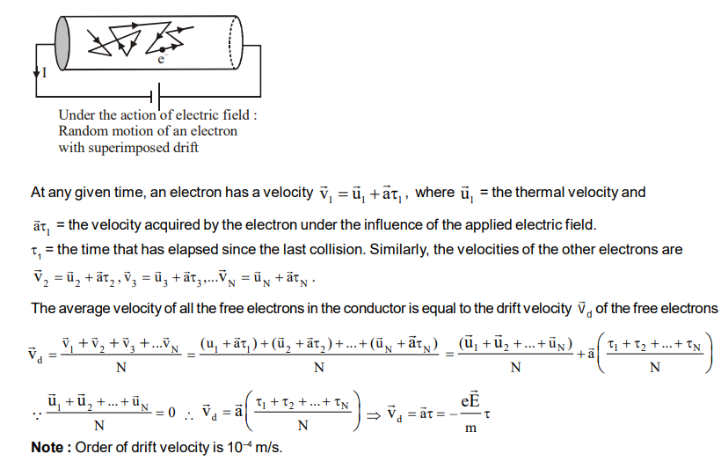
Drift velocity is defined as the velocity with which the free electrons get drifted towards the positive terminal under the effect of the applied external electric field.

Current density at any point inside a conductor is defined as a vector having magnitude equal to current per unit area surrounding that point. Remember area is normal to the direction of charge flow (or current passes) through that point.
J = dq/dt n

